Introduction

In this lab, we had two implementations of digital filters for two different times of averages and tested their hardware cost and performance. And tested the implementation with external stimuli on FPGA.

The system

The top design file MAC_gen_min_full.vhdl has contains 7 components - MAC_gen_min_12_17, two convert_data_format, sample_clock, SPI_clock, SPI_AD, and SPI_DA with some signal lines. SPI_AD and the following converter modules can convert the analog signal into digital signed_data, filtered by the MAC_gen_min_12_17. After through the converter module again, the filtered signal is converted to analog data by SPI_DA module. SPI_clock and sample_clock can create the clock_enable signals.

The MAC_gen_min_full module is for the average filter algorithm. It calculates the filtered data using the average from a finite number of input data sampled. The finite number is the number of TAPs, which is decided by GENERIC parameters. The SIGNAL_WIDTH and COEFF_WIDTH in GENERIC decide the data line width for calculation – **DA_data/AD_data** between SPI_DA/SPI_AD and converter, **filtered_data/signed_data** between converter and MAC_gen_min. Therefore, they control the hardware area (more TAPs, more area), critical set-up time constraints (more TAPs, longer time), dynamic power (because wider data lines mean more states in SPI_FSM so that a greater number of bits to be flipped), and energy per operation.

In lab 3, we have seen that the SPI_DA converts the parallel data into serial data by FSM. SCLK_enable signal from the block SPI_CLK decides how much and how long the FSM is. When we want the wordlengths of signal is 17, the necessary number of FSM is 17 (regardless of configuration and others), which means, the valid number of SCLK_enable is 17 to change the states converting. SCLK_en and sample_en are generated from the frequency dividers. SPI_CLK block, for example, has a counter counting the number of rising edge of system clk, and when it comes to the PERIOD_constant we set, the SCLK_en will reverse. So the period of output clock is PERIOD_constant multiplying the system period.

The highest system clock frequency we found is about 41.7 MHz with a 0.171 ns slack. In lab3, the highest frequency is 51 MHz, higher than 41.7 MHz. It may be because of some converter combinational blocks on the critical path. The hardware utilization is also different from those in lab 3. It has 70 more LUTs and some DSPs in this design. DSP accounts for 5% of resources near the 6% IO. And the new serial design has same structure as the previous. The highest frequency we found is 1/9.2 = 10.9 MHz.

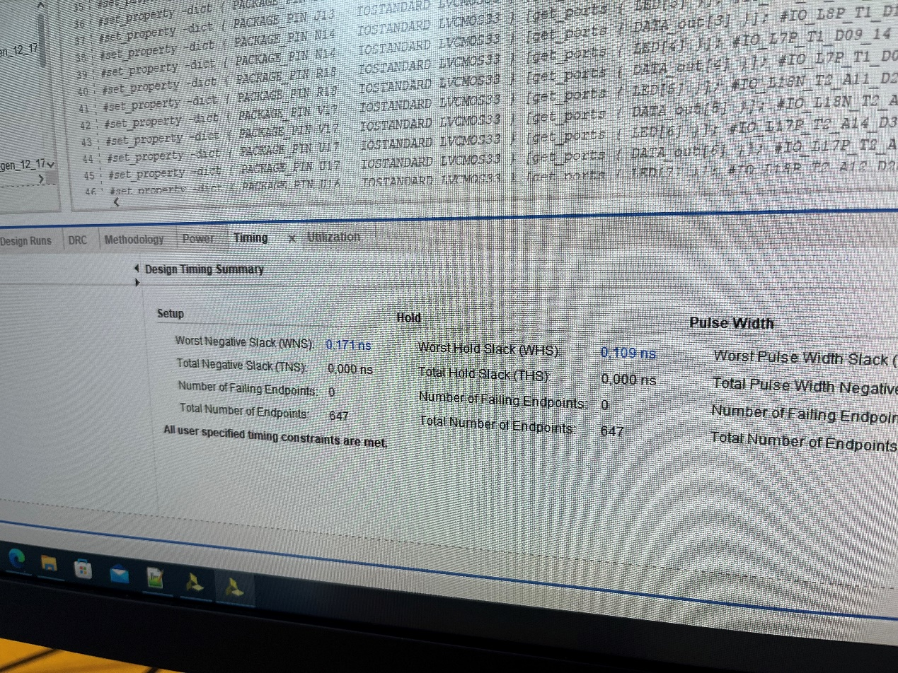

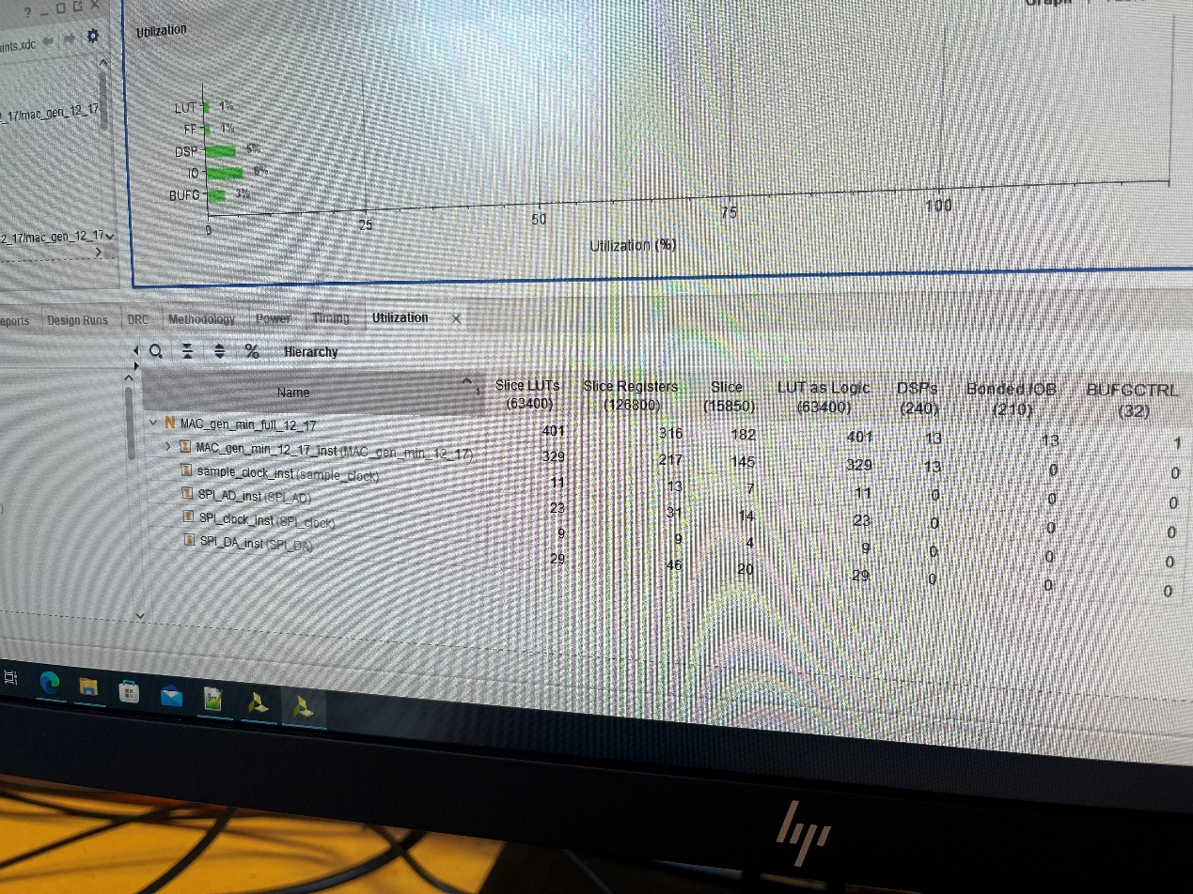

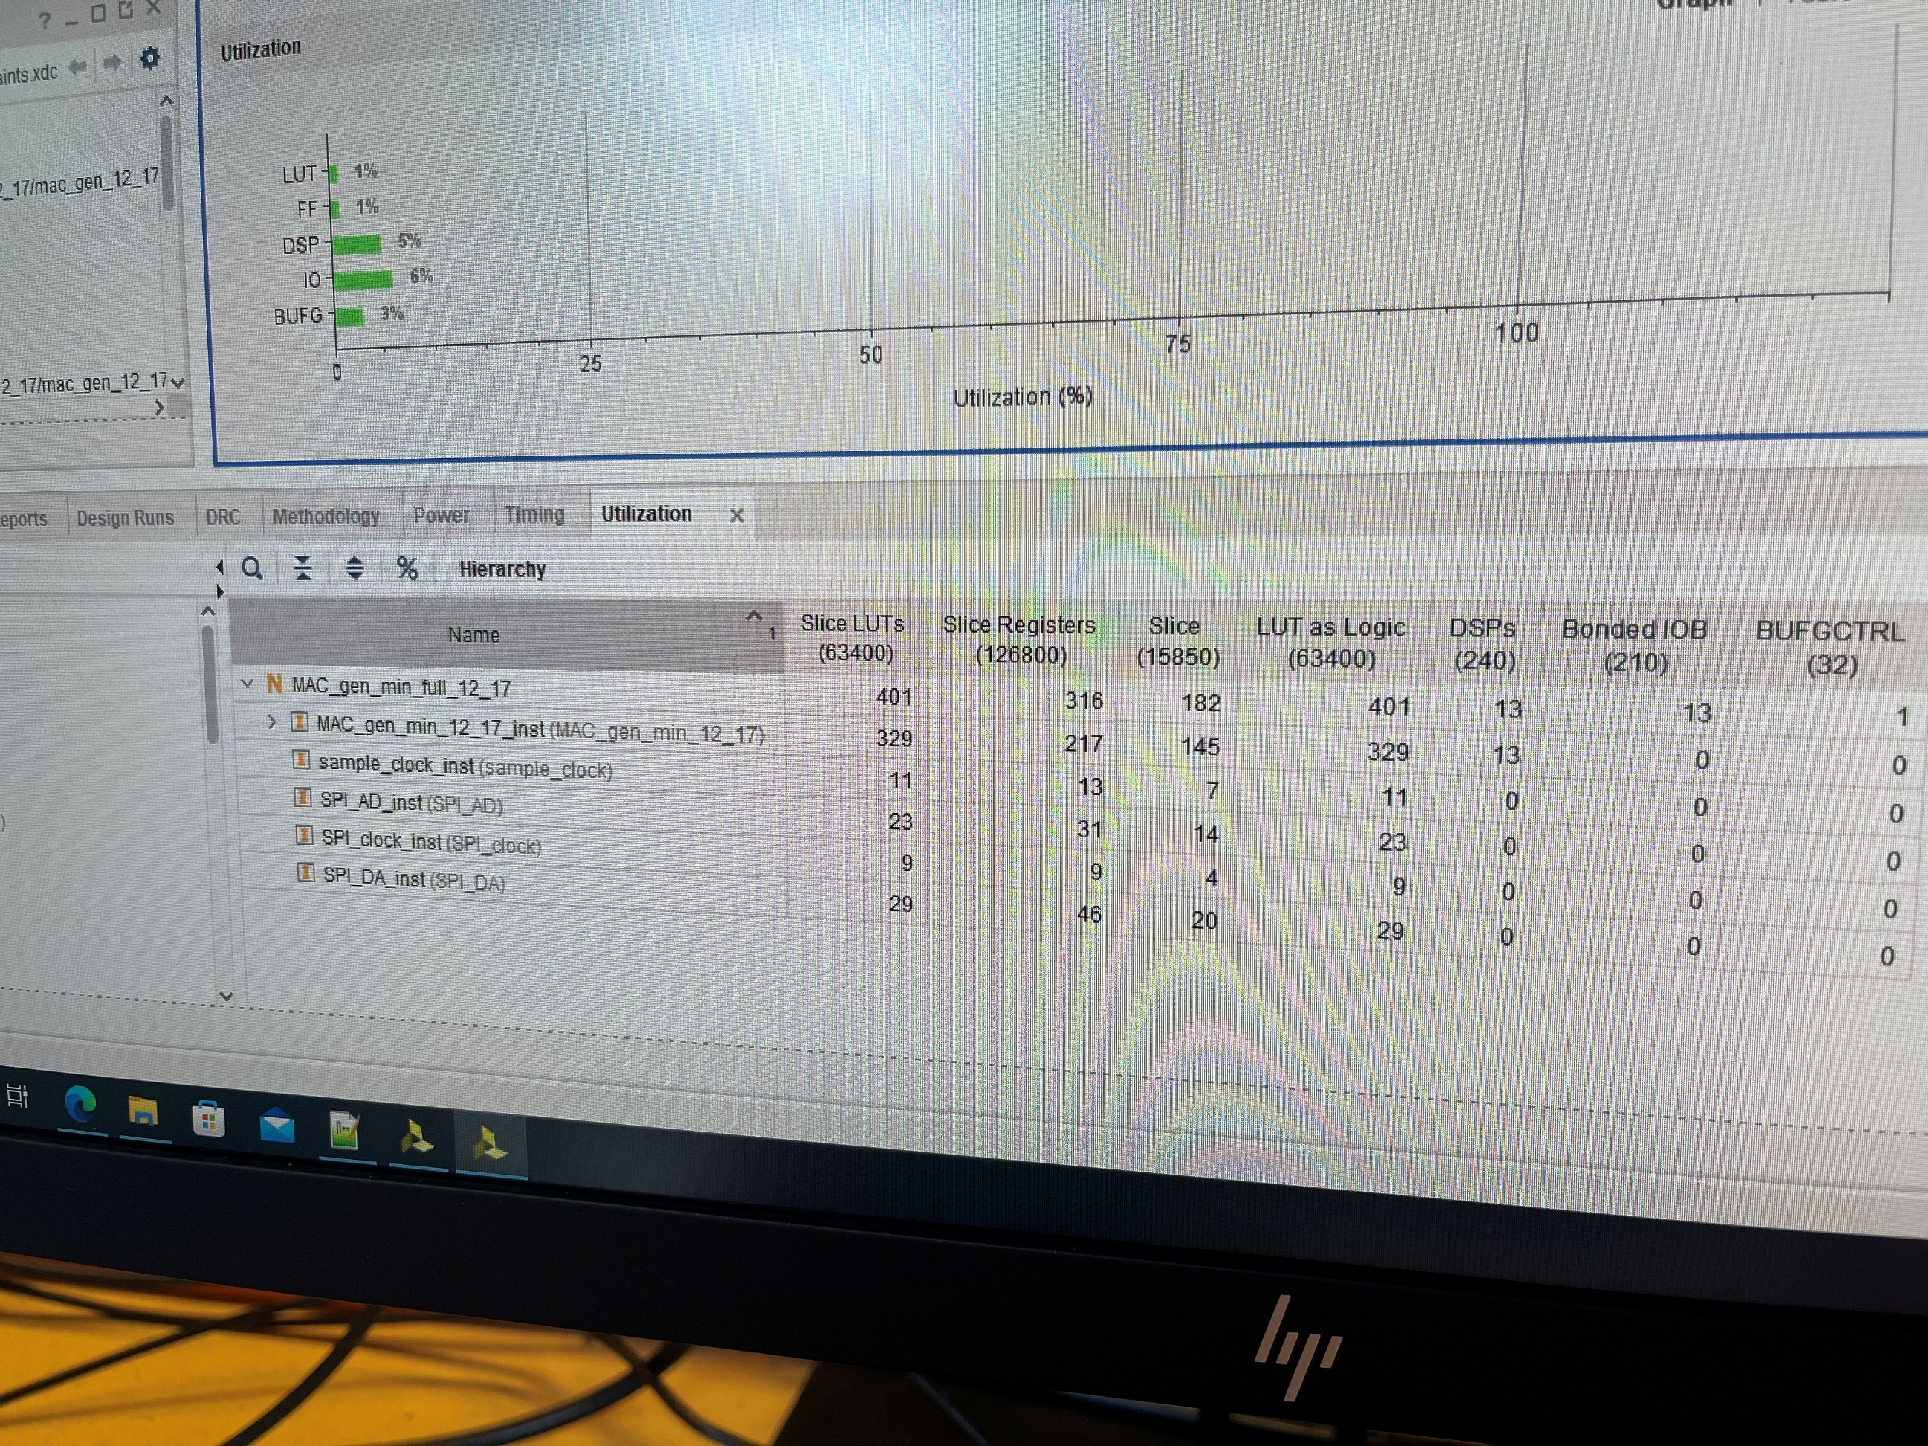

Exexute on FPGA

We set the 1 KHz sinewave 1Vpp signal on AD input and used the oscilloscope to monitor this signal on channel 2 and DA output on channel 1. The output amplitude is related to the input signal frequency. We scanned the frequency from zero up and found when it came to 10.86 KHz, it would reduce to about $\frac{660}{940}=1∕\sqrt{2}$. It means this design is a low-pass filter with 10.86 KHz cutoff frequency.

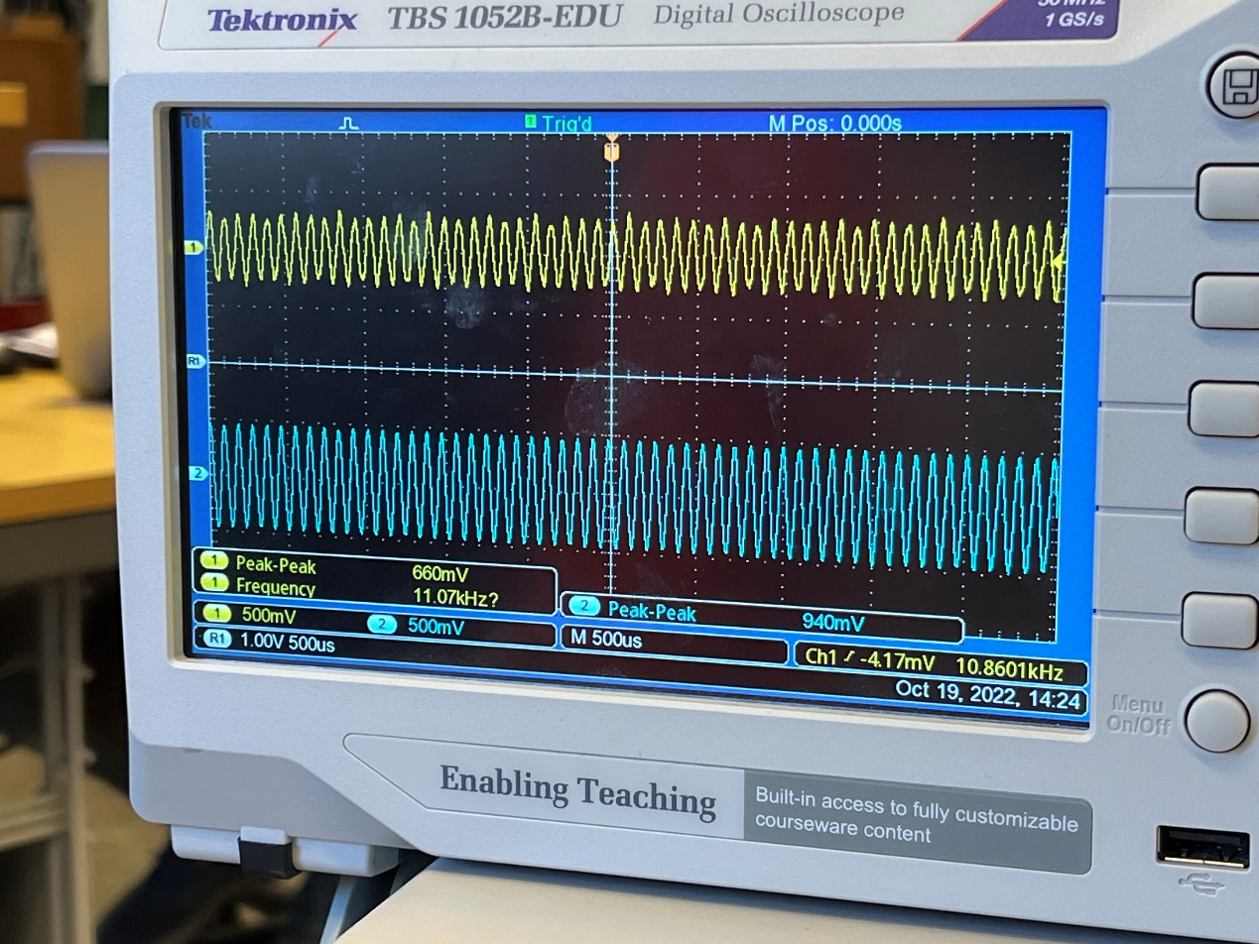

A second parameter set

The differences in the MAC_gen_min are bigger than those in the MAC_gen_ser. As the number of TAPs increases, the resource utilization for MAC_gen_min is bigger, mainly the DSP resource, increasing from 5% to 23%. LUT is 2780 more than the previous number. And the highest frequency is about 1/124ns = 8.1 MHz with a 0.8 ns slack.

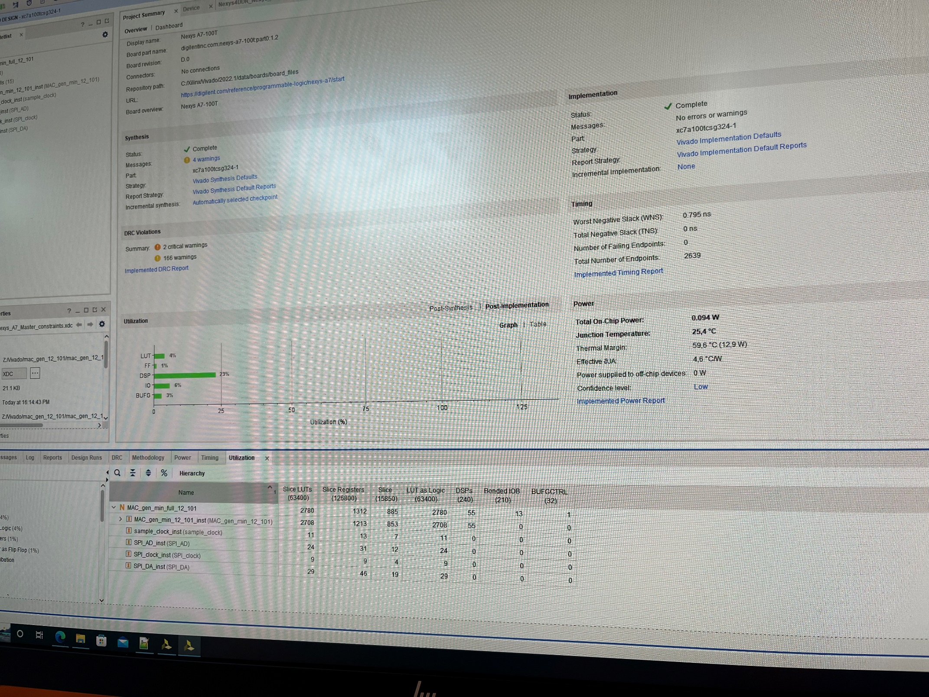

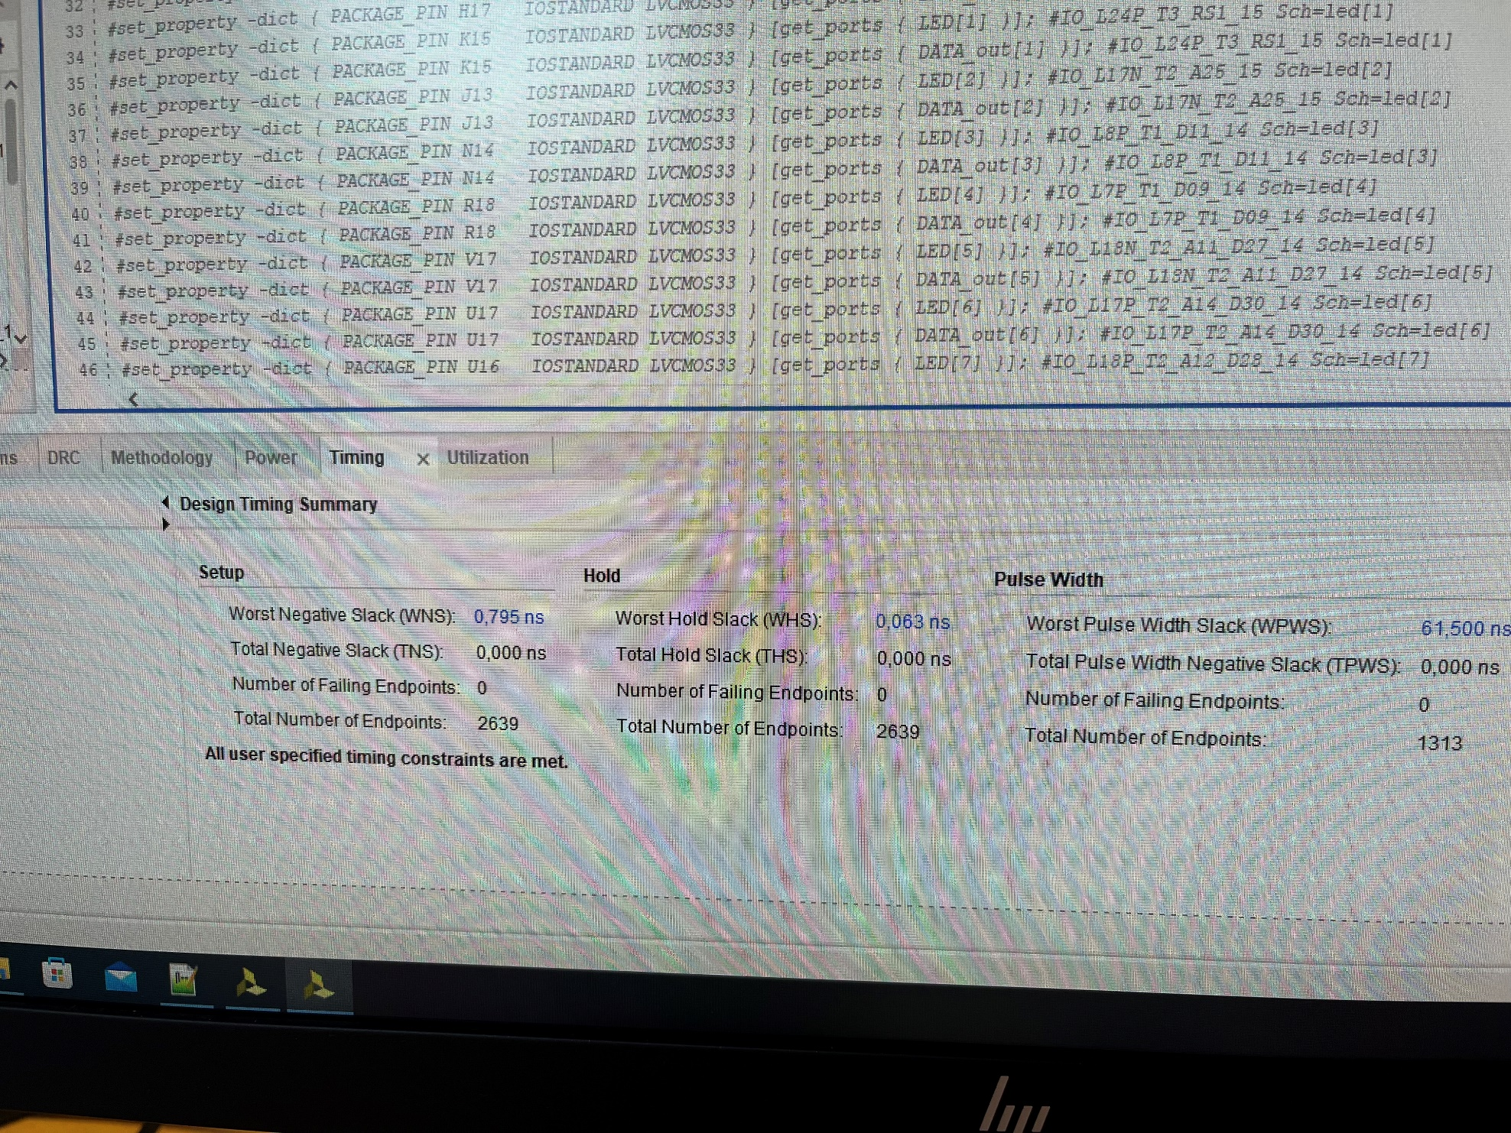

Another difference is in the frequency domain. This one is a band-pass filter rather than low-pass filter. Its cutoff frequency is 8.14 KHz and 12.84 KHz.

Summary

Several filters have several algorithms, performances, hardware utilizations, and signal processing quality. Even if the same algorithm is, the different implementations will result in differences. If we want the smoother FIR filtered signal, we may need more TAPs, but it will change the frequency domain. So we need to make some trade-off also in the insights of signal processing.